**UNIVERSITY OF DAR ES SALAAM**



**COLLEGE OF INFORMATION AND COMMUNICATION TECHNOLOGIES**

**DEPARTMENT OF COMPUTER SCIENCE AND ENGINEERING**

**IS 676: GEOSPATIAL DATA MANAGEMENT**

**ASSIGNMENT 5**

|  |  |
| --- | --- |
| **NAME:** | NASHY HABIBU |
| **REG No.:** | 2023-06-00215 |
| **PROGRAMME:** | MASTER OF SCIENCE IN DATA SCIENCE |

**Submission date: 22-June-2024**

**TASK**

Suitability analysis for school development in Dar es Salaam.

Given data:

* **Dar River**: schools are to be built 2000m away.
* **Dar main roads**: schools are to be built at most 2000m away from the center of the road.
* **Land Use**: to extract protected areas, by which schools are to be built 2000m away.
* **Dar boundary**: to guide area restricted.

**DATA PREPROCESSING**

1. Dar Road

|  |  |  |
| --- | --- | --- |
| Class | Buffer | Suitability |
| 1 | < 2000m | Suitable |
| 2 | > 2000m | Unsuitable |

Creating road map with 2000m buffer, as illustrated in Figure 1.

[Analysis Tools 🡪 Proximity 🡪 Buffer]

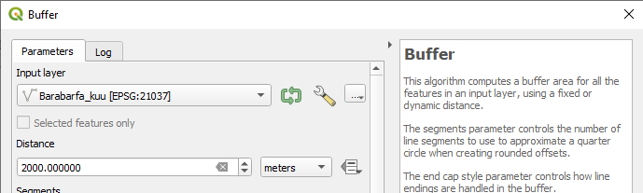

Figure 1: Creating Road buffer

1. River

|  |  |  |
| --- | --- | --- |
| Class | Buffer | Suitability |
| 1 | > 2000m | Suitable |
| 2 | < 2000m | Unsuitable |

Creating river map with 2000m buffer, as illustrated in Figure 2.

[Analysis Tools 🡪 Proximity 🡪 Buffer]

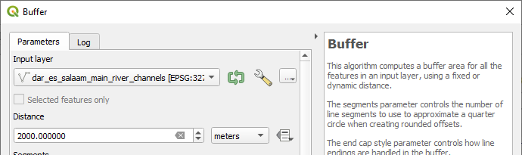

Figure 2: Creating River buffer

1. Land use

|  |  |  |
| --- | --- | --- |
| Class | Buffer from protected area | Suitability |
| 1 | < 2000m | Suitable |
| 2 | > 2000m | Unsuitable |

Figure 3 shows Land use map of Dar es salaam.

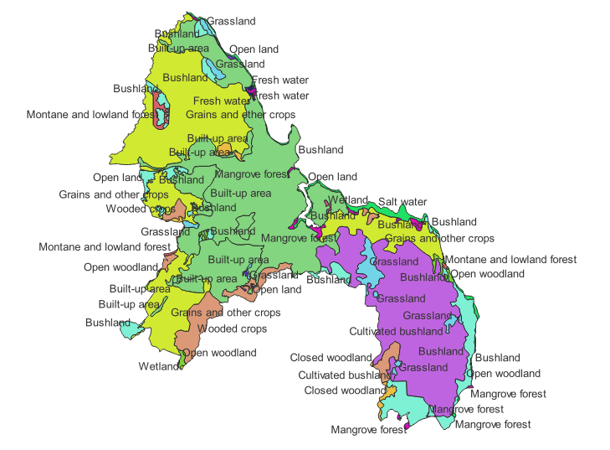

Figure 3: Land use map

**DETERMINING SUITABLE AREA**

1. Dissolving Road buffer

[Vector 🡪 Geoprocessing Tools 🡪 Dissolve]

Figure 4 illustrates before and after dissolving the road buffer layer.

|  |  |
| --- | --- |
|  |  |

Figure 4: Dissolved Road layer (before and after)

ii. Dissolving River buffer

[Vector 🡪 Geoprocessing Tools 🡪 Dissolve]

Figure 5 illustrates before and after dissolving the river buffer layer.

|  |  |
| --- | --- |
|  |  |

Figure 5: Dissolved River layer (before and after)

iii. Erasing Road buffer layer by river buffer layer

[Vector 🡪 Geoprocessing Tools 🡪 Difference]

Figure 6 and 7 shows Difference operation and the create layer after respectively.

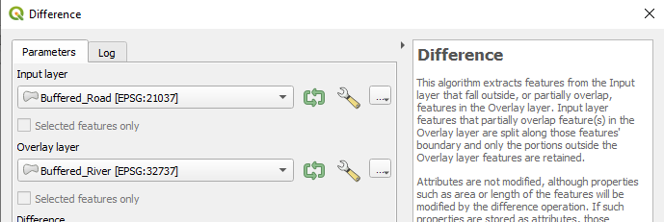

Figure 6: Difference operation

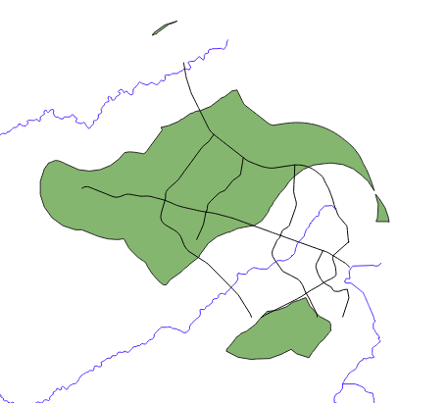

Figure 7: Created layer after erasing

iv. Checking if the created layer falls under a protected area from land use map

The created layer falls on to Open land, Built-up area, Closed woodland and Bush land. Figure 8 shows both land use layer and the created layer. Thus, there is no any portion of the created layer that falls on protected area as instructed.

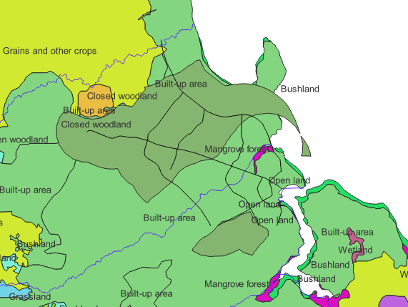

Figure 8: Created layer on Land use layer

v. Creating a clipped layer with reference to Dar boundary layer

[Vector 🡪 Geoprocessing Tools 🡪 Clip]

Figure 9 and 10 illustrates clip operation and clipped layer respectively.

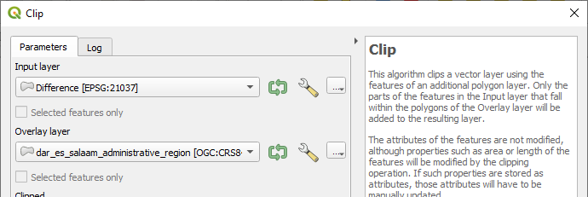

Figure 9: Clip operation

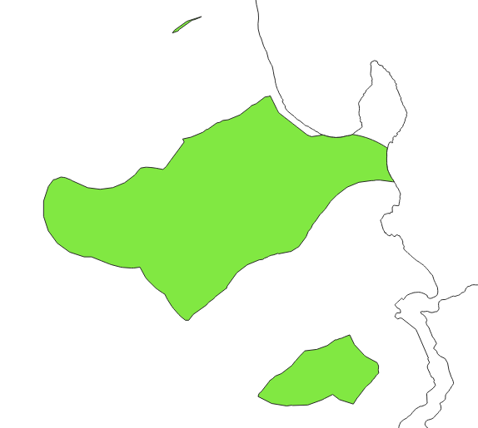

Figure 10: Clipped layer

Figure 11 shows the final map layout.

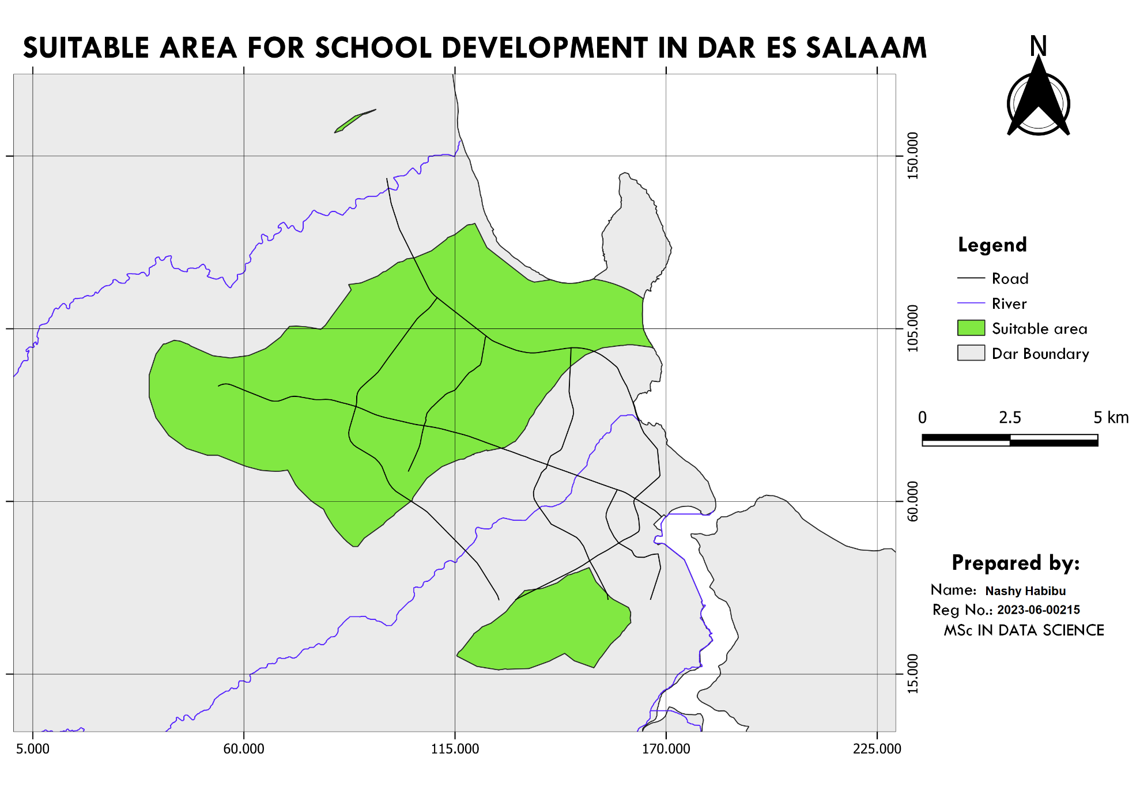

Figure 11: Map layout